**Online Examination System using HTML form and JAVA Servlet**

EX5.HTML

**PROGRAM:**

**Index.html**

<!DOCTYPE html>

<html lang="en">

<head>

<meta charset="UTF-8">

<meta name="viewport" content="width=device-width, initial-scale=1.0">

<title>Online Exam</title>

</head>

<body>

<h2>Online Exam Form</h2>

<form action="Sathya" method="post">

Name: <input type="text" name="username" required><br><br>

1.what is your name?<br>

<input type="radio" name="q1" value="Sathya" required> Sathya<br>

<input type="radio" name="q1" value="Shivani"> Shivani<br>

<input type="radio" name="q1" value="Dharshini"> Dharshini<br><br>

2.what is your native place?<br>

<input type="radio" name="q2" value="Chennai" required> Chennai<br>

<input type="radio" name="q2" value="Virudhunagar"> Virudhunagar<br>

<input type="radio" name="q2" value="Kovilpatti"> Kovilpatti<br><br>

4.who is your favorite person?<br>

<input type="radio" name="q3" value="Amma" required> Amma<br>

<input type="radio" name="q3" value="Appa"> Appa<br>

<input type="radio" name="q3" value="Akka"> Akka<br><br>

4.what is your favourite colour?<br>

<input type="radio" name="q4" value="Blue" required>Blue <br>

<input type="radio" name="q4" value="Pink"> Pink<br>

<input type="radio" name="q4" value="Green"> Green<br><br>

5.what is your Goal?<br>

<input type="radio" name="q5" value="IPS" required> IPS<br>

<input type="radio" name="q5" value="IAS"> IAS<br>

<input type="radio" name="q5" value="IFS"> IFS<br><br>

<input type="submit" value="Submit">

</form>

</body>

</html>

**Servlet:**

import java.io.IOException;

import java.io.PrintWriter;

import javax.servlet.ServletException;

import javax.servlet.annotation.WebServlet;

import javax.servlet.http.HttpServlet;

import javax.servlet.http.HttpServletRequest;

import javax.servlet.http.HttpServletResponse;

/**

*

* @author 23ucs113

*/

@WebServlet(urlPatterns = {"/Sathya"})

public class Sathya extends HttpServlet {

/**

* Processes requests for both HTTP <code>GET</code> and <code>POST</code>

* methods.

*

* @param request servlet request

* @param response servlet response

* @throws ServletException if a servlet-specific error occurs

* @throws IOException if an I/O error occurs

*/

protected void processRequest(HttpServletRequest request, HttpServletResponse response)

throws ServletException, IOException {

String username=request.getParameter("username");

String q1=request.getParameter("q1");

String q2=request.getParameter("q2");

String q3=request.getParameter("q3");

String q4=request.getParameter("q4");

String q5=request.getParameter("q5");

int score=0;

if("Sathya".equals(q1)){

score++;

}

if("Chennai".equals(q2)){

score++;

}

if("Amma".equals(q3)){

score++;

}

if("Green".equals(q4)){

score++;

}

if("IPS".equals(q5)){

score++;

}

response.setContentType("text/html");

PrintWriter out=response.getWriter();

out.println("<html><body>");

out.println("<h2>Result</h2>");

out.println("Name:"+username+"<br>");

out.println("score:"+score+"/5");

out.println("</body></html>");

}

// <editor-fold defaultstate="collapsed" desc="HttpServlet methods. Click on the + sign on the left to edit the code.">

/**

* Handles the HTTP <code>GET</code> method.

*

* @param request servlet request

* @param response servlet response

* @throws ServletException if a servlet-specific error occurs

* @throws IOException if an I/O error occurs

*/

@Override

protected void doGet(HttpServletRequest request, HttpServletResponse response)

throws ServletException, IOException {

processRequest(request, response);

}

/**

* Handles the HTTP <code>POST</code> method.

*

* @param request servlet request

* @param response servlet response

* @throws ServletException if a servlet-specific error occurs

* @throws IOException if an I/O error occurs

*/

@Override

protected void doPost(HttpServletRequest request, HttpServletResponse response)

throws ServletException, IOException {

processRequest(request, response);

}

/**

* Returns a short description of the servlet.

*

* @return a String containing servlet description

*/

@Override

public String getServletInfo() {

return "Short description";

}// </editor-fold>

}

**Output:**

**Online Quiz**

Top of Form

Name:   
  
1.what is your name?  
 Sathya  
 Shivani  
 Dharshini  
  
2.what is your native place?  
 Chennai  
 Virudhunagar  
 Kovilpatti  
  
4.who is your favorite person?  
 Amma  
 Appa  
 Akka  
  
4.what is your favourite colour?  
Blue  
 Pink  
 Green  
  
5.what is your Goal?  
 IPS  
 IAS  
 IFS

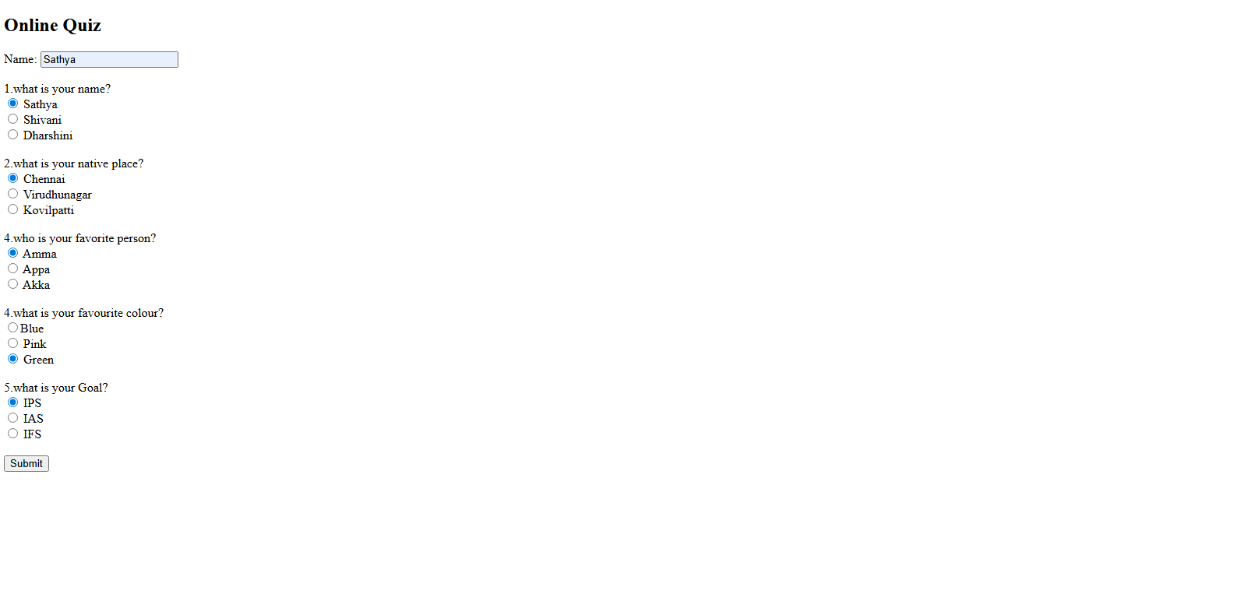

Bottom of Form

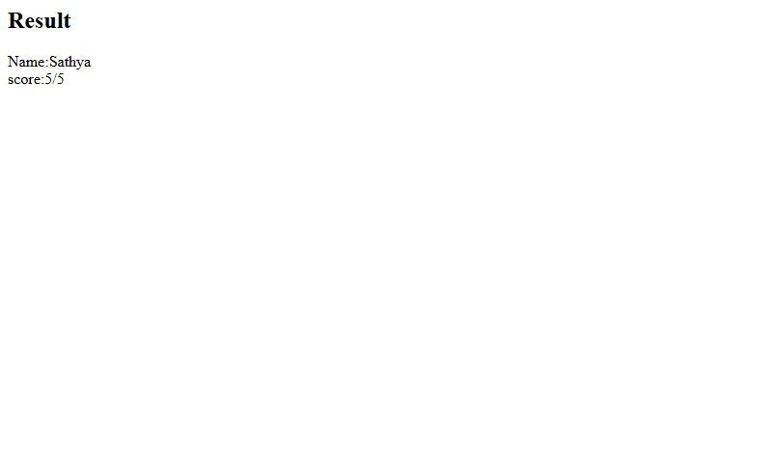

**Github Link:**